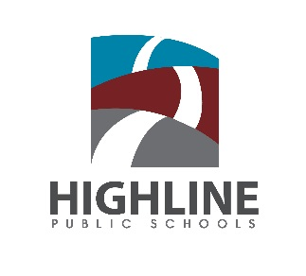
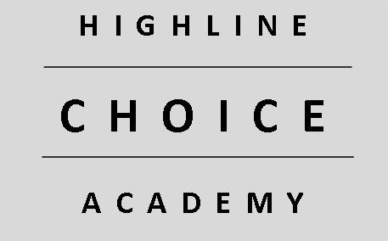
Highline CHOICE Academy
18367 8th Ave S.
Burien, WA 98148

Join us for our annual OPEN HOUSE
January 17, 2019
6:30 p.m.

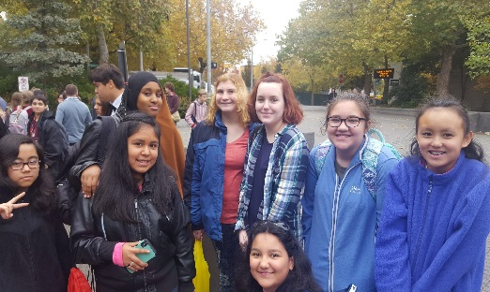
Serving Grades 6-12

We provide all students with a safe and supportive learning environment which emphasizes academic excellence, personal intergrity and social responsibility.

Application Process for 2019-2020 School Year
- On-line applications are available at: highlineschools.org/CHOICE
- January 1-January 31: Application window opens and closes
- February 1-22: Application Review
- March 1: Lottery Day
- March 1-March 28: Family Interviews

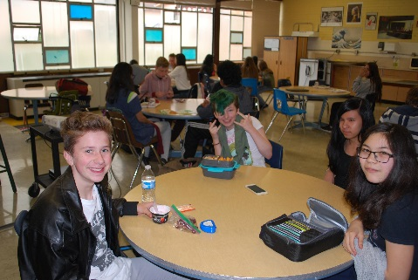
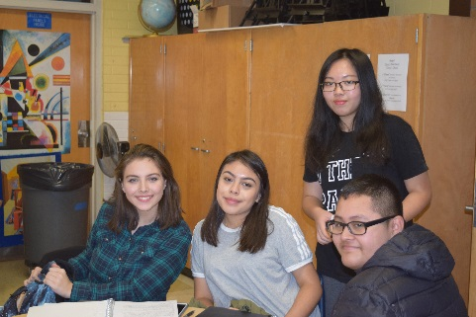

Recipient of the 2017and 2018 Washington State School of Distinction

